**LAB 3B**

**Name: Hồ Đức Trí**

**Student No: 1912288**

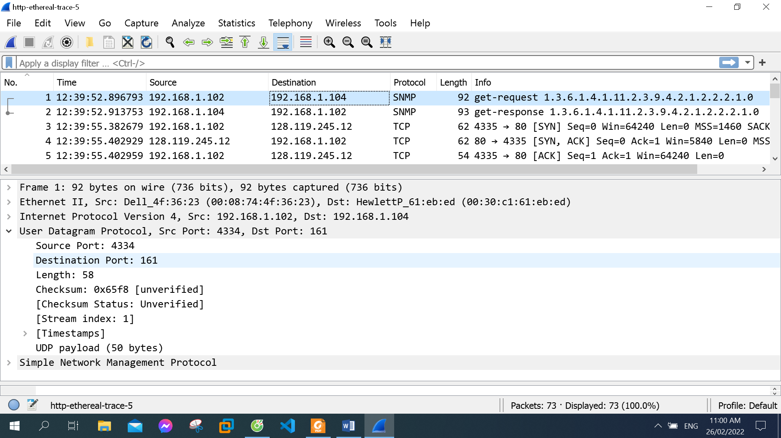

1. Select one UDP packet from your trace. From this packet, determine how many fields there are in the UDP header. Name these  fields.

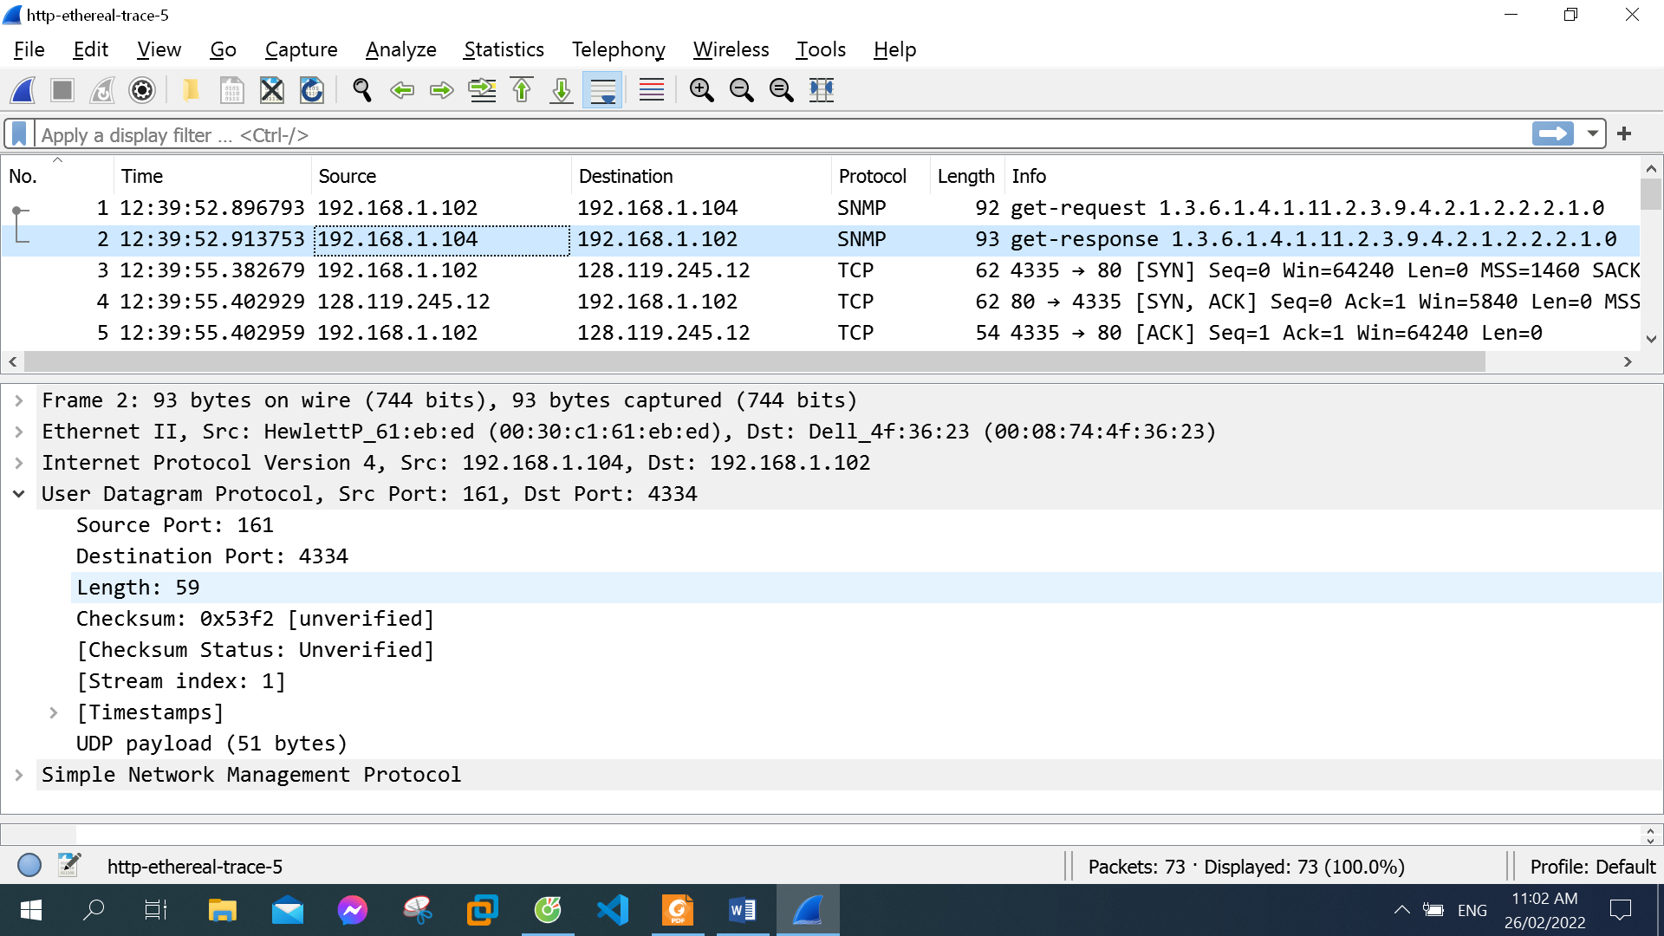

4 fields: Source Port, Destination Port, Length, Checksum

1. By consulting the displayed information in Wireshark’s packet content field for  this packet, determine the length (in bytes) of each of the UDP header fields.

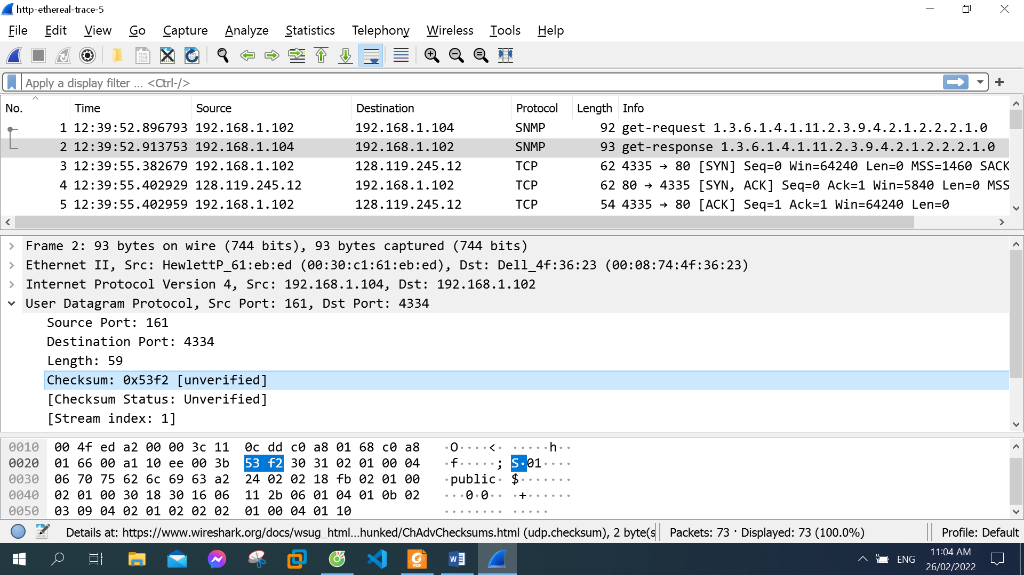

The length of each of the UDP header fields is 2 bytes

1. The value in the Length field is the length of what? (You can consult the text for this answer). Verify your claim with your captured UDP packet.

The value 59 in the Length field is the length of 8 bytes UDP packet header plus 51 bytes UDP payload

1. What is the maximum number of bytes that can be included in a UDP payload? (Hint: the answer to this question can be determined by your answer to 2. above)

The maximum number of bytes that can be included in a UDP payload:

2^16 - 1 - 8 = 65527 bytes (8 bytes of header fields)

1. What is the largest possible source port number? (Hint: see the hint in 4.)

The largest possible source port number: 2^16 - 1 = 65535

1. What is the protocol number for UDP? Give your answer in both hexadecimal and decimal notation. To answer this question, you’ll need to look into the Protocol field of the IP datagram containing this UDP segment (see Figure 4.13 in the text, and the discussion of IP header fields).

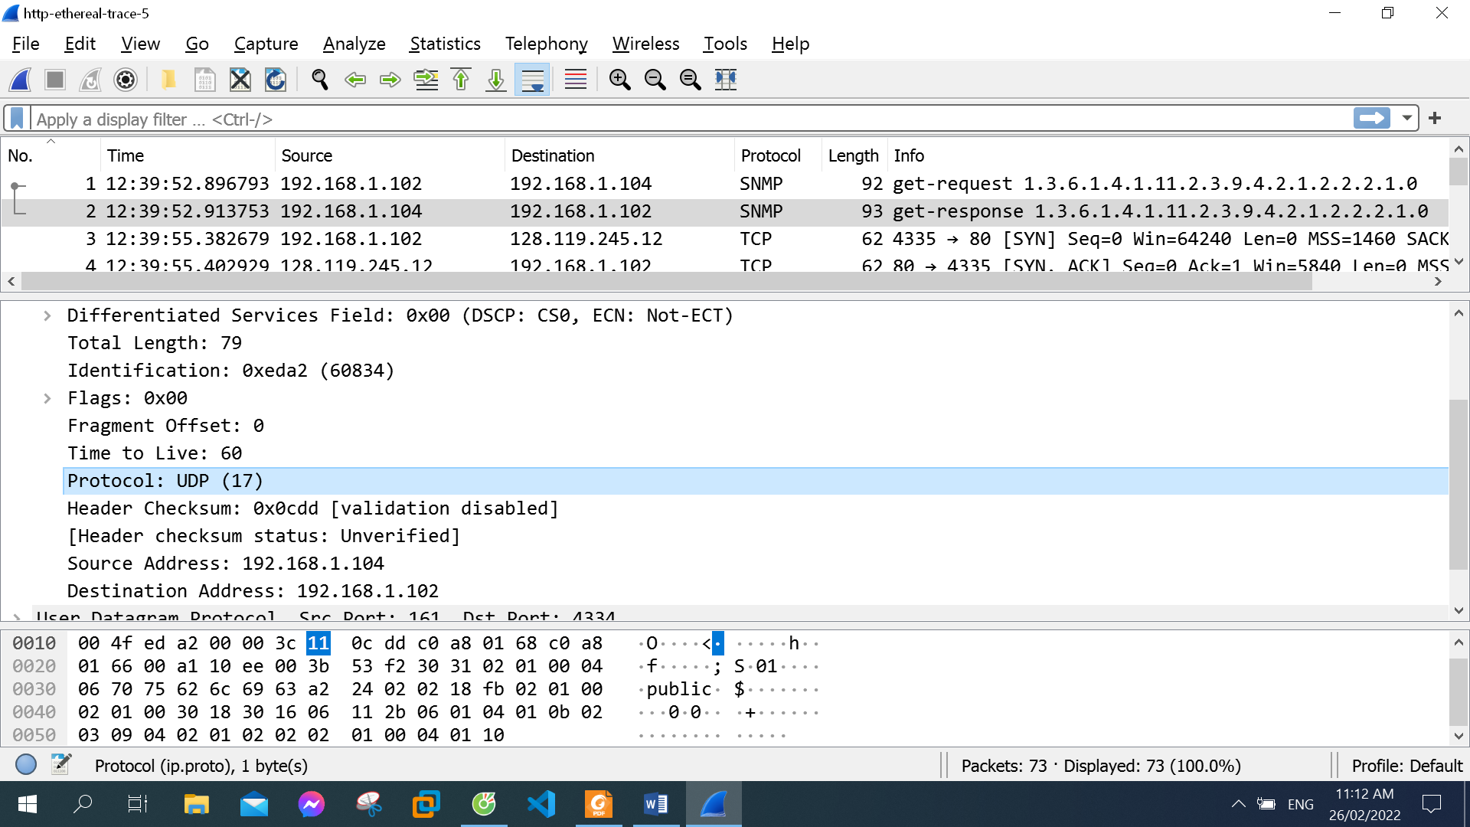

The protocol number in decimal for UDP: 17

The protocol number in hexadecimal for UDP: 11

1. Examine a pair of UDP packets in which your host sends the first UDP packet and the second UDP packet is a reply to this first UDP packet. (Hint: for a second packet to be sent in response to a first packet, the sender of the first packet should be the destination of the second packet). Describe the relationship between the port numbers in the two packets.

First UDP packet my host sent

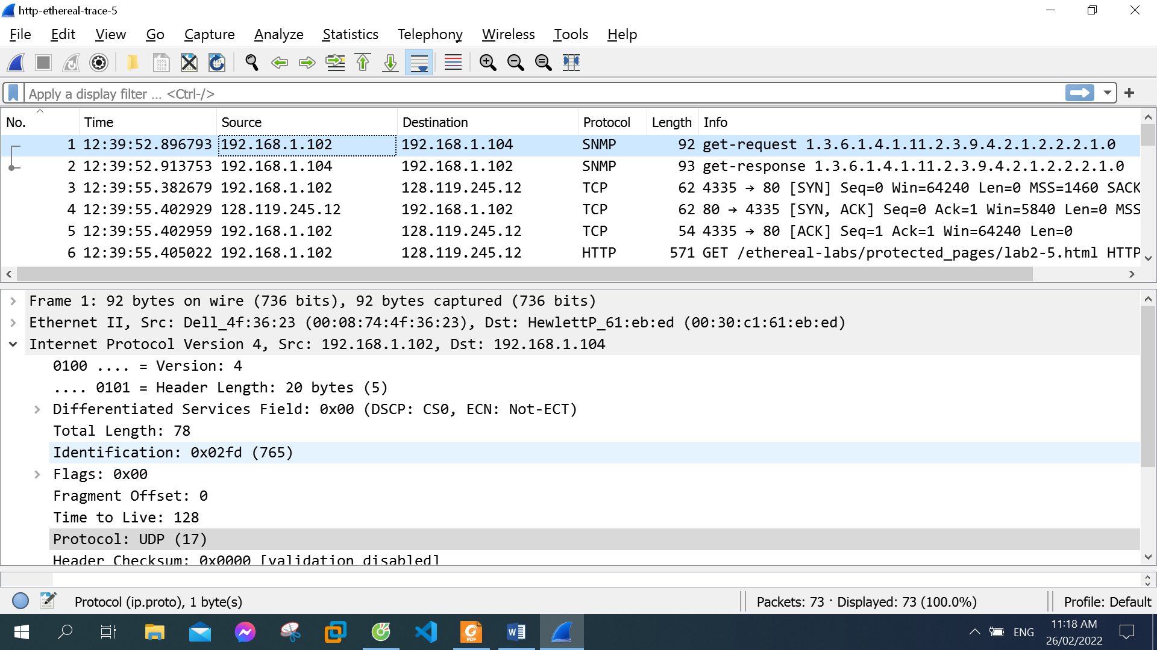

UDP packet that reply to the first UDP packet

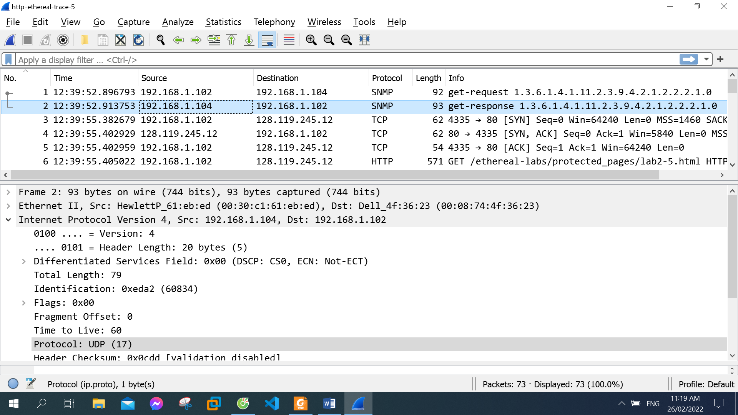

Source port in the first packet is destination port in the second packet, destination port in the first packet is source port in the second packet